Training Day – 31

Topic:\* Introduction to Matplotlib

* Learned to create simple line plots.
* Example: Plotted y = x^2 for x in range 0 to 10.

Matplotlib is a powerful and versatile open-source plotting library for Python, designed to help users visualize data in a variety of formats. Developed by John D. Hunter in 2003, it enables users to graphically represent data, facilitating easier analysis and understanding. If you want to convert your boring data into interactive plots and graphs, Matplotlib is the tool for you.

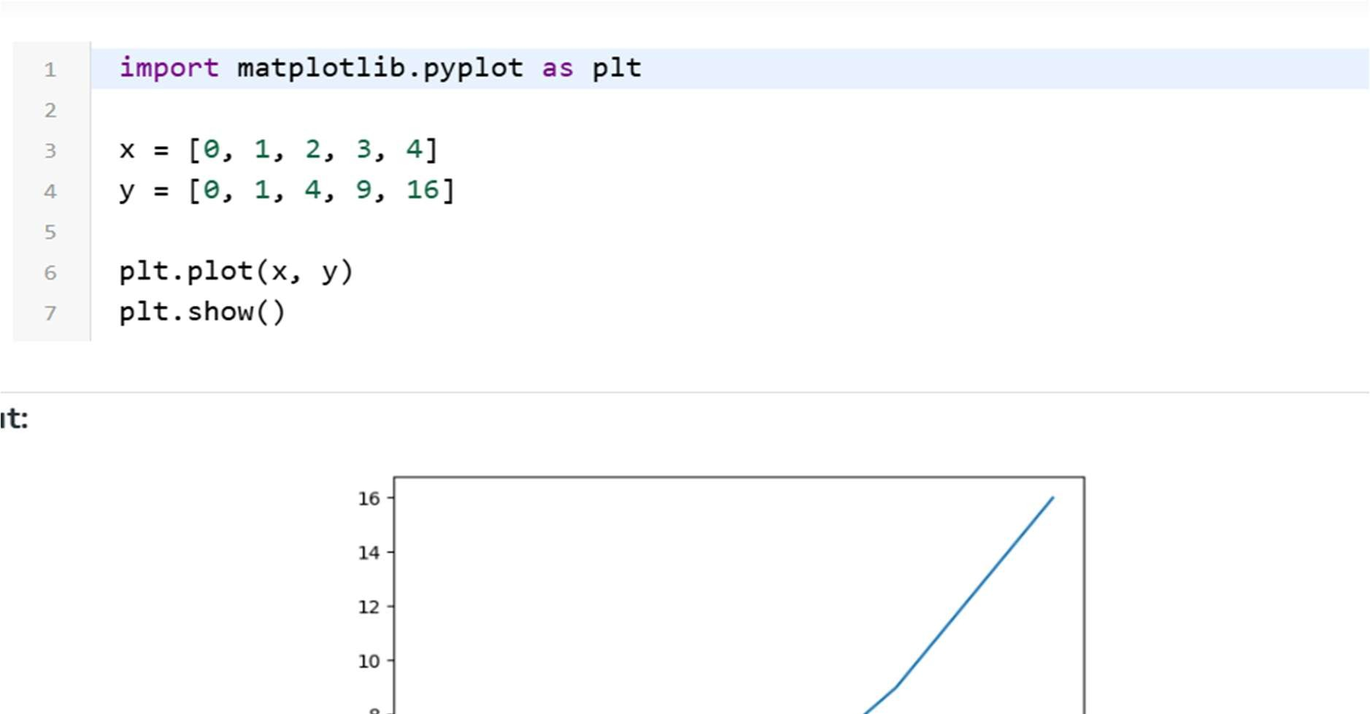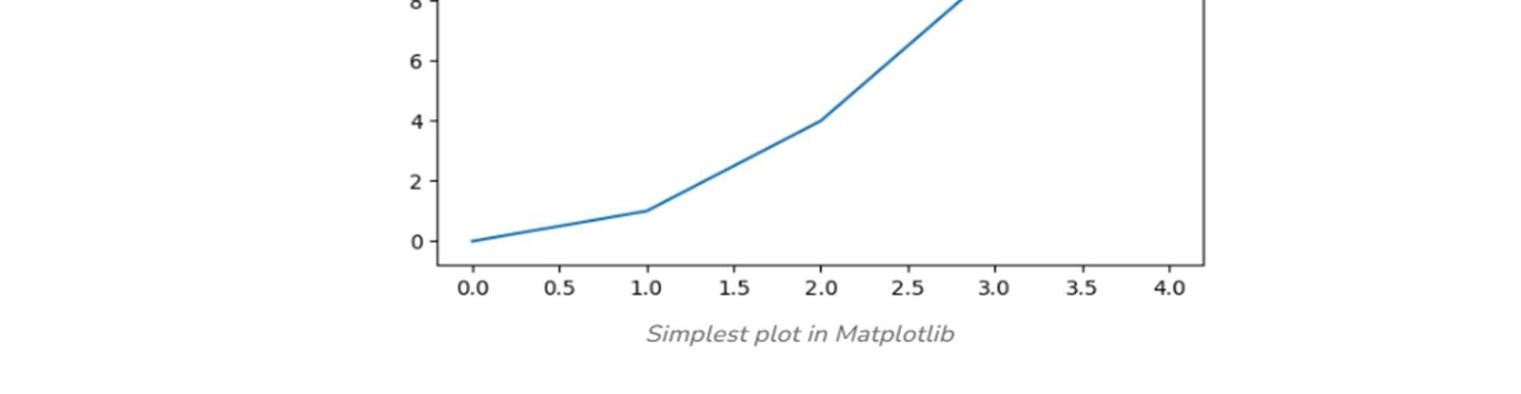

* + Import Matplotlib: Start by importing matplotlib.pyplot as plt.
  + Create Data: Prepare your data in the form of lists or arrays.
  + Plot Data: Use plt.plot() to create the plot.
  + Customize Plot: Add titles, labels, and other elements using methods like plt.title(), plt.xlabel(), and plt.ylabel().
  + Display Plot: Use plt.show() to display the plot.